IAM NOTES
IAM: Identity Access Management
IAM identity --> identity can be user,group,roles.
Policy:
Policy defines the permissions of the IAM identity.
Types of policies:
1) Identity Based policies:
InLine Policy:
An inline policy is a policy created for a single IAM identity (a user, group, or role).
Inline policies maintain a strict one-to-one relationship between a policy and an identity.
They are deleted when you delete the identity.
Managed Policies:
1) Aws Managed Policy
2) Customer Managed Policy
AWS managed policies – Managed policies that are created and managed by AWS.
Customer managed policies – Managed policies that you create and manage in your AWS
account. Customer managed policies provide more precise control over your policies
than AWS managed policies.
2) Resource-based policies:
Are attached directly to resources and specify permissions for specific actions on the resource by some principals.
3) IAM permissions boundaries:
Define the maximum permissions for an IAM entity and are used as safeguards.
4) Access control lists(ACLs):
Are attached to resources and control cross-account permissions for principals from other accounts.
5) Organizations Service Control Policies(SCPs):
Specify the maximum level of permissions for an organization’s accounts. These policies are used to limit the permissions that can be assigned within member accounts.
6) Session policies:
Are advanced policies used during temporary sessions for roles or federated users.
Role:
IAM role is an identity within your AWS account that has specific permissions.
It is similar to an IAM user, but is not associated with a specific person.
Types of Roles?
1) Aws service Role:
A service role is an IAM role that a service assumes to perform actions on your behalf.
2) AWS account:
Allow entities in other AWS accounts belonging to you or a 3rd party to perform actions in this account.
3) Web identity:
Allows users federated by the specified external web identity provider to assume this role to perform actions in this account.
4) SAML 2.0 federation (Security Assertion Markup Language ):
Allow users federated with SAML 2.0 from a corporate directory to perform actions in this account.
5) Custom trust policy:
Create a custom trust policy to enable others to perform actions in this account.

What is Identity and Access Management(IAM)?
AWS Identity and Access Management (IAM) is a web service that helps you securely control access to AWS resources. You use IAM to control who is authenticated (signed in) and authorized (has permissions) to use resources. It is the backbone of security in your AWS account.
When you first create an AWS account, you begin with a single sign-in identity that has complete access to all AWS services and resources in the account. This identity is called the AWS account root user.
IAM allows you to move beyond the root user by creating other users and granting them specific permissions according to their roles. The key features of IAM are:
- Centralized Control of Your AWS Account: You can manage all users and their permissions from a single place.
- Granular Permissions: Go beyond simple "admin" or "user" roles. You can specify exactly which actions (e.g., ec2:StartInstances) are allowed on which specific resources (e.g., only a particular EC2 instance).
- Global Service: IAM is not tied to a specific AWS region. IAM users, groups, and roles are created globally.
- Free to Use: IAM is a feature of your AWS account offered at no additional charge. You are charged only for the use of other AWS services by your IAM users.
The Core Components of AWS IAM (The "Identities")
IAM is built on several core components that represent "who" can access your account.
1. AWS Account Root User
This is the all-powerful identity created when you first open your AWS account. It has unrestricted access to everything, including billing information and the ability to close the account.
Best Practice: The Root User should not be used for everyday tasks. Its credentials should be secured, Multi-Factor Authentication (MFA) should be enabled, and it should only be used for tasks that explicitly require it. Instead, you should create a separate IAM user with administrative privileges for daily management.
2. IAM Users
An IAM User is an entity you create in AWS to represent a person or an application that needs to interact with your AWS resources. A user has long-term credentials:
- A password for access to the AWS Management Console.
- Access keys (access key ID and secret access key) for programmatic access via the API or CLI.
3. IAM Groups
An IAM Group is simply a collection of IAM Users. Groups are the best way to manage permissions for multiple users at once. Instead of attaching permission policies to each individual user, you attach them to a group. When a user is added to that group, they automatically inherit all of its permissions. This simplifies management and reduces the chance of error.
4. IAM Roles
A Role is the most flexible and secure way to grant permissions. A Role is an identity with permission policies, but it does not have its own long-term credentials like a password or access keys.
Instead, when an entity (like an IAM User, an application, or an AWS service) needs access, it temporarily assumes the Role. The Role then provides temporary security credentials for that session.
Common Use Case: Allowing an EC2 instance to access an S3 bucket. Instead of storing AWS access keys in your application code on the EC2 instance (a major security risk), you would:
- Create a Role with a policy that grants read access to the S3 bucket.
- Attach that Role to the EC2 instance.
- The application running on the EC2 instance can then automatically retrieve temporary, rotated credentials from the Role to securely access the S3 bucket.
Feature | IAM User | IAM Group | IAM Role
Purpose | Represents a specific person or application with long-term credentials. | A logical container to simplify permission management across users. | A temporary identity assumed by trusted entities for specific tasks.
Credentials | Permanent (password, access keys). | None; not an identity. | Temporary, automatically rotated credentials.
Use for Humans | Rarely used for direct access; reserved for administrative or break-glass scenarios. | Assign common permissions (e.g., Developers, Auditors). | Grant short-term, elevated, or cross-account access.
Use for Services | Not recommended due to long-term key risks. | Not applicable. | Best practice for service-to-service access (e.g., EC2 → S3).
How Identity and Access Management Works?
IAM Policies can be applied to AWS resources like EC2 instances, RDS Databases, and S3 Buckets. Permissions are defined using actions (e.g., RunInstances), resources (e.g., arn:aws:ec2:region:account-id:isntance/*) and conditions (e.g., only if certain tag is present).

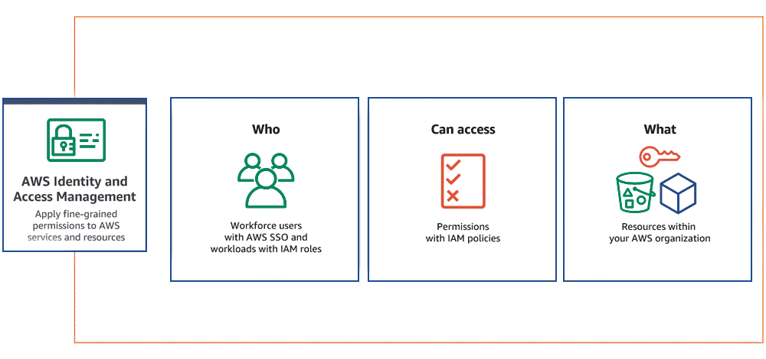
Access Management
Access Management is the core of IAM. It involves defining who can access what in AWS and what actions they can take. IAM allows you to grant permissions based on the principle of least privilege -giving users only the permissions they need to perform their tasks.
Federation
Federation in IAM allows users from external identity providers (e.g., corporate directions or social logins) to access AWS resources. It enables Single Sign-On (SSO) capabilities, improving security and simplifying user management.
Role-Based Access Control (RBAC)
RBAC helps control access based on users' roles within an organization. With RBAC, you can define permissions for roles e.g., admin, developer, or viewer) and assign these roles to users, rather than assigning permissions to each user individually.
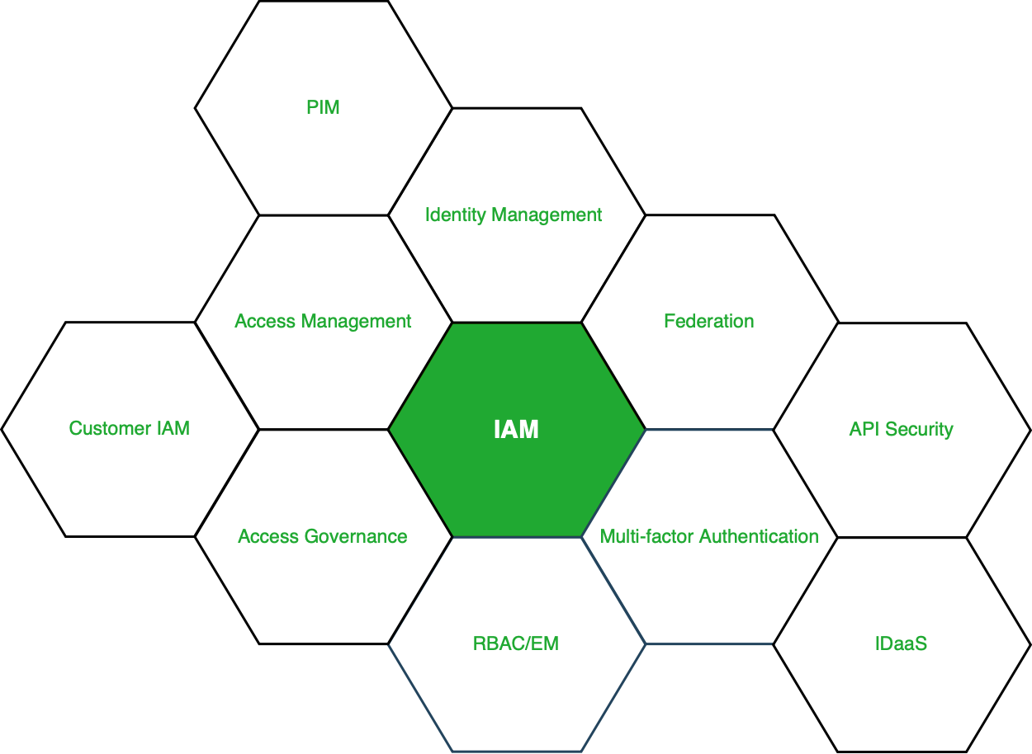Figure - Services under IAM
Types of Permissions in IAM
Allow Permissions
An explicit "allow" permission grants the user, group, or role access to a resource. For Example, an IAM user with the "s3:ListBucket" permission can list the content of anS3 Bucket.
Deny Permissions
A "deny" permission explicitly prevents access to a resource. This can be set for security reasons, such as denying access to sensitive resources for certain users.
Implicit Deny
By Default, if no policy is attached to a user, group, or role, access to a resource is denied. IAM denies access if no explicit allow rule is present.
Type | Description | Example
Allow | Grants access to perform specified actions. | s3:ListBucket allows listing bucket contents.
Explicit Deny | Overrides any allow rule to block access. | Deny access to production S3 buckets for non-admin roles.
Implicit Deny | Default state; if no policy explicitly allows access, it is denied. | A new user with no attached policies cannot access any resource.
How to Set up IAM in AWS: Step by Step Process
Setting up IAM involves creating users, groups, roles, and policies that define what resources and actions are allowed. Below is a simple process for getting started:
Step 1: Create an IAM Users
- Open the IAM Console and click Users → Add User.
- Enter the username, select the access type (e.g., programmatic or console access), and assign permissions.
Step 2: Create an IAM Group
- Go to IAM Console >> Groups >> Create New Group
- Add users to this group and assign a set of policies (permissions).
Step 3: Enable MFA (Multi-Factor Authentication)
- To enhance security, enable MFA for critical IAM users (such as admins). MFA adds an extra layer of protection by requiring users to provide a second form of authentication (e.g., a mobile app).
Step 4: Create IAM Roles
IAM roles can be created for cross-account access or to give AWS services permissions to interact with each other (E.g., EC2 needs access to S3).
AWS IAM Best Practices
- Lock Away Your Root User Credentials: Do not use the root user for daily tasks. Enable MFA on it and store the credentials securely.
- Enforce the Principle of Least Privilege: Always grant only the minimum permissions required for a user or application to perform its task. Start with nothing and add permissions as needed.
- Use Groups to Assign Permissions to Users: Never attach policies directly to individual users.
- Use Roles for Applications and AWS Services: This avoids the need to manage long-term access keys.
- Enable Multi-Factor Authentication (MFA): Add an extra layer of security for all your users, especially privileged ones.
- Rotate Credentials Regularly: Implement a policy to rotate passwords and access keys periodically.
IAM Technologies and Tools
- Single Sign-On (SSO): A choice that lets a user login and use multiple applications at once, as well as give more security to the services. Example: Its competitors include Okta and Microsoft Azure AD.
- Multi-Factor Authentication (MFA): A second one is that you must verify your account with two or more ways to boost its security. Example: Some of the examples of Two Factor Authentication applications are Duo Security and Google Authenticator.
- Role-Based Access Control (RBAC): Secures the system based on employees’ roles, where the user will have the least privilege to access the system. Example: IBM Security Identity Manager.
- Privileged Access Management (PAM): Performs functions associated with obtaining and maintaining high levels of accessible (“privileged”) computing resources. Example: CyberArk, Beyond Trust.
Resource Access Control
Identity and access management (IAM) will allows you to manage the permissions to the resources in the AWS cloud like users who can access particular service to which extent and also instead of maintaining the permissions individually you can manage the permissions to group of users at a time.
- Managing permissions: For example you want to assign an permission to the user that he/her can only perform restart the instance task on AWS EC2 instance then you can do using AWS IAM.
- Implementing role-based access control(RBAC): Identity and Access Management (IAM) will helps you to manage the permissions based on roles Roles will helps to assign the the permissions to the resources in the AWS like which resources can access the another resource according to the requirement.
- Enabling single sign-on (SSO): Identity and Access Management will helps you to maintain the same password and user name which will reduce the effort of remembering the different password.
IAM Features
Shared Access to your Account: A team working on a project can easily share resources with the help of the shared access feature.
- Free of cost: IAM feature of the AWS account is free to use & charges are added only when you access other Amazon web services using IAM users.
- Have Centralized control over your AWS account: Any new creation of users, groups, or any form of cancellation that takes place in the AWS account is controlled by you, and you have control over what & how data can be accessed by the user.
- Grant permission to the user: As the root account holds administrative rights, the user will be granted permission to access certain services by IAM.
- Multifactor Authentication: Additional layer of security is implemented on your account by a third party, a six-digit number that you have to put along with your password when you log into your accounts.

